Commands -:

“_____ According to Wikipeida”

**Chrome Automation-:**

“Open Google” or “search google”- or “ok google ____search_______”

To close tab- ” close this tab”

To open homepage – “Homepage”

To open new tab – “open new tab”

To go first tab – “first tab”

To reset browser zoom – “reset browser zoom” or “default browser size”

To goto next tab – “next tab”

To see dictionary - : “open dictionary”

To go to last tab – “last tab”

To press eneter- just say - “enter”

For cut copy paste just say – “cut” , “copy ”, “paste”

To open bookmark manager – “open bookmark manager”

To open file in browser – “open file in browser”

Go to browser history – “browser histroy” or“history”

To open new browser – “new broswer”

To close window – “close this window”

To open incognito mode – “private mode”

To refresh page – “refresh page”

To save page – “save this page”

To reopen closed tab – “reopen”or “reopen tab”

To open start –“open/close start”

To change the window – “change the window”

To hide all folders - : “hide all files”

To unhide it – “visible”

To know battery power – “how much power is left” or “battery status”

To calculate – : “do some calculation” or “open calculator”

To open any website - : “open website” or “website ________”

To open/close “open/close word file”

Tell a joke

To open/close aftereffect notepad photoshop torrent telegram- “open/close after effect/telegram/photoshop/torrent/notepad”

To know some place that where it is just say – “where is ___place name___”

For shutdown or restart or sleep – “shutdown/restart/hibernate the system”

To lock the window – “lock window”

“Jarvis/sofia voice” “tell about yourself”

To send mail –“send mail” “mail”

To know tempretare – “temperature”

To see insta profile – “open Instagram profile”

To take screenshot – “take screenshot”

To know news – “tell me News”

“remember that” “what do u remeber”

Tell my ipadfress – “my ipadress”

To send whatsapp message – “send whatsapp message”

To search on youtube –“youtube search ---------?”

“Volume up/down----decrease/Increase volume mute”

To know out location – “Tell my location”

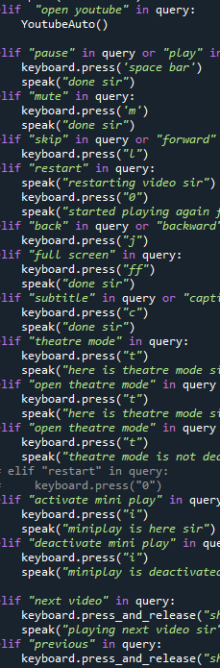

**MODULES_:**

Sys and OS -:we are using for to so that we can deal with filename , path , and directories

**pyttsx3 -we are gonna use this for text to speech conversion in our model**

**datetime – this we are gonna use for so we can know from interpreter current date and time.**

**speech recognition – this we are gonna use for our spoken words are understood by machine and then it will identifiy them .**

**Wikipedia –this we are gonna use to extract data from wikiepdia and give us**

**Instaloder-**he Instaloader module is **a Python package having great functionalities to scrap instagram**, we will be using this for to download: Posts of public/private account. stories. IGTV and even prfile pictrue

**Webbrowser-** this module gives **a basic interface to the system's standard web browser**. It provides an open function, which takes a filename or a URL, and displays it in the browser. We are gonna use it to manipulate web browser of google automation and youtube as per our convinces .

**Pywhatkit-** this we are gonna use for **sending Whatsapp messages at a certain time**.

**,pyautogui – this we are gonna use for to get control to keyboard and mouse of our system**

**, psutil –**this we are gonna use to keep track of various resources utilization in the system. Like Usage of resources like CPU, memory, disks, network, sensors can be monitored.

**Operator- this we are gonna use to perform basic calucations**

**, pyjokes- this we are gonna use to get 1 line jokes .**

**, playsound – thiswe are gonna use to playsong /music as per our convince ,**

**pyDictionay.**